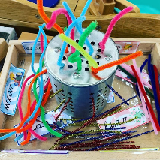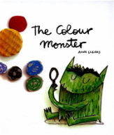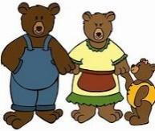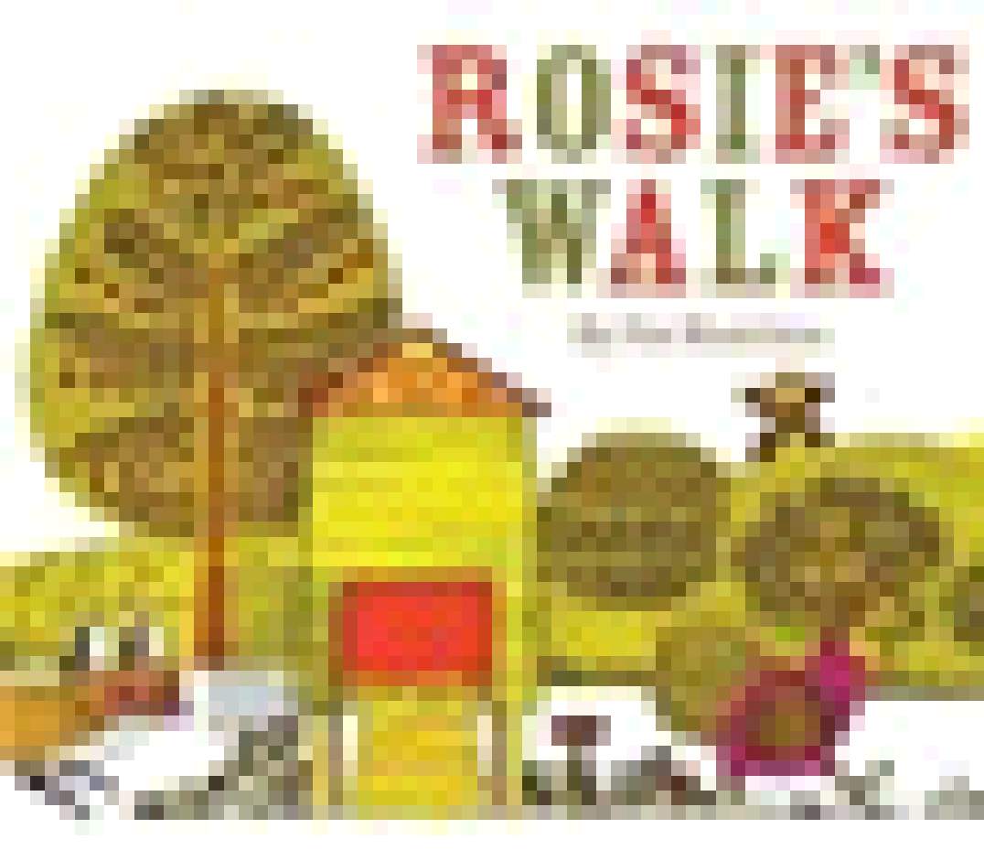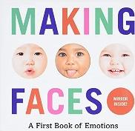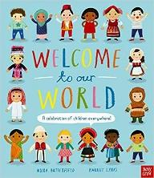

**Prime Area: Physical Development (PD)**

We are so lucky to take part in:

Yoga session (See description below)

We have a funky finger table set up with different activities each week to promote fine motor skills.

We take part in a PE lesson once a week – this term our focus is

We have fabulous open ended outdoor resources chosen to challenge our fine and gross motor development.

Hula Hoop day

**Primer Area: Communication and Language (CL)**

We will take part in circle times to start to learn how to become confident talkers and listens to others.

We will start to listen and take parts in story times.

We will learn new nursery rhymes

We will sing new songs

We will begin to learn and use Makaton



Our traditional Tales are: Goldilocks and the Three Bears and Little Red Riding Hood.