English  In English we are will be starting with a short film telling the story of ‘The Black Hat’. Year 3 will be writing detailed descriptions of the creatures in the story, focussing on rich, ambitious language. We will be creating some rainforest-inspired poetry, and writing non-chronological reports about rainforests.  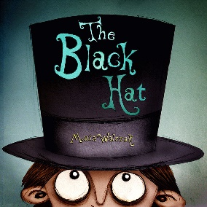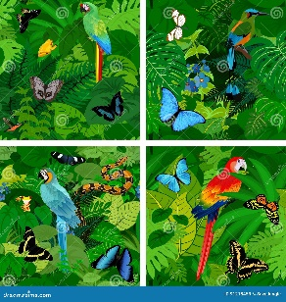 | 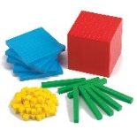  Maths  In Maths we will be learning various methods - mental and formal written methods - in Multiplication & Division, and begin to learn the 3x, 4x and 8x tables, and recapping 2x, 5x and 10x tables.  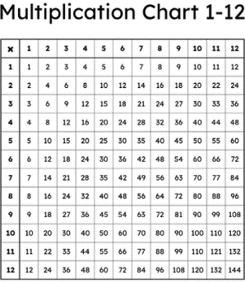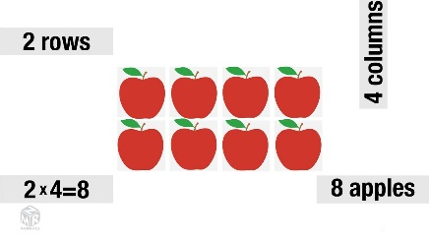 | Science  In Science this term we carry on with our topic ‘Rocks, Soils and Fossils’. We will be learning about how fossils are made and that there are different forms of fossil. We will also be learning about what soil is and how soils can differ.  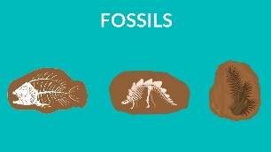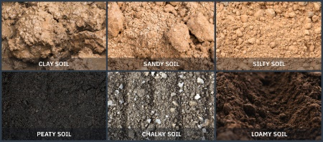
P.E & French  PE this half term will take the form of either Forest School or Commando Joe’s, depending on which group your child is in. Year 3 will also be swimming every Tuesday.  In French we use the Language Angels programme. Through lots of verbal practice, we will learn how to locate France, Paris and a few key cities on a map. We will also learn how to say our name, how we are feeling, learn up to 10 colours and count from 1-10 in French.  This Photo by Unknown Author is licensed under CC BY-NC | Year 3 Curriculum Plan  Enrichment  Books we will read together  ‘The Sheep Pig’ (Vipers guided reading sessions).  ‘The Great Kapok Tree’ | Computing & Design Technology  In Computing, we will be learning about Branching Databases and creating questions that give ‘yes’ or ‘no’ answers, allowing for sorting of objects.  In Art, we will be recreating a painted picture by Cezanne in the style of a different artist – Matisse. Children will use shape and colour to explore Matisse’s style, creating collages in response to Cezanne’s still life oil painting.  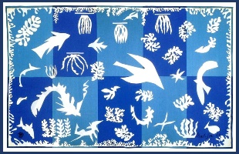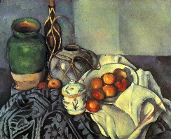
Creative Arts  In Music we will be following the Charanga programme, learning songs to sing and playing chime bars. We will also be listening to a range of music and appraising what we hear. | Topic  In Geography we will be learning about rainforests; where they are in the world; what their climates are like; what wildlife can be found in a rainforest, and the layers than make up a rainforest. We will also be learning about the impacts of humans on rainforests and how rainforests can be protected.  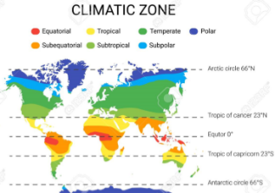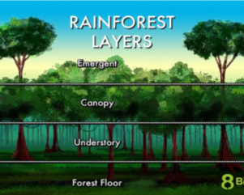 | RE  In RE we are focussing on the question ‘How do festivals and worship show what matters to a Muslim?’  