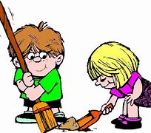

***Nursery Medium Term Plan***

***Spring***

*Following in the moment planning, children can demonstrate and are supported to demonstrate statements from the seven different areas during any term in their individual learning pathway. Lots of children may demonstrate these statements during this term.*

**Prime Area: Physical Development (PD)**

Collaborate with others to manage large items, such as moving a long plank safely, carry large hollow bricks.

Use one handed tools and equipment.

Use a comfortable grip with good control when holding pens and pencils.

Learning to use a knife and fork when eating.

Show a preference for a dominant hand.

**Specific Area: Literacy (L)**

Develop their phonological awareness, so they can:

- Spot and suggest rhymes

- Count and clap syllables in a word

- Recognise words with the same initial sound such as money and mud.

Use some of their print and letter knowledge in their early writing.

Write some or all of their name.

Write some letters accurately.

Recognise and say compound words



**Specific Area: Understanding the World (UW)**

Understand the key features of the life cycle animal.

Begin to understand the need to respect and care for the natural environment and all living things.

Continue to develop positive attitudes about the differences in people.

Know there are different countries in the world and talk about the differences they have experienced or seen in photos.

