**Hexham First School**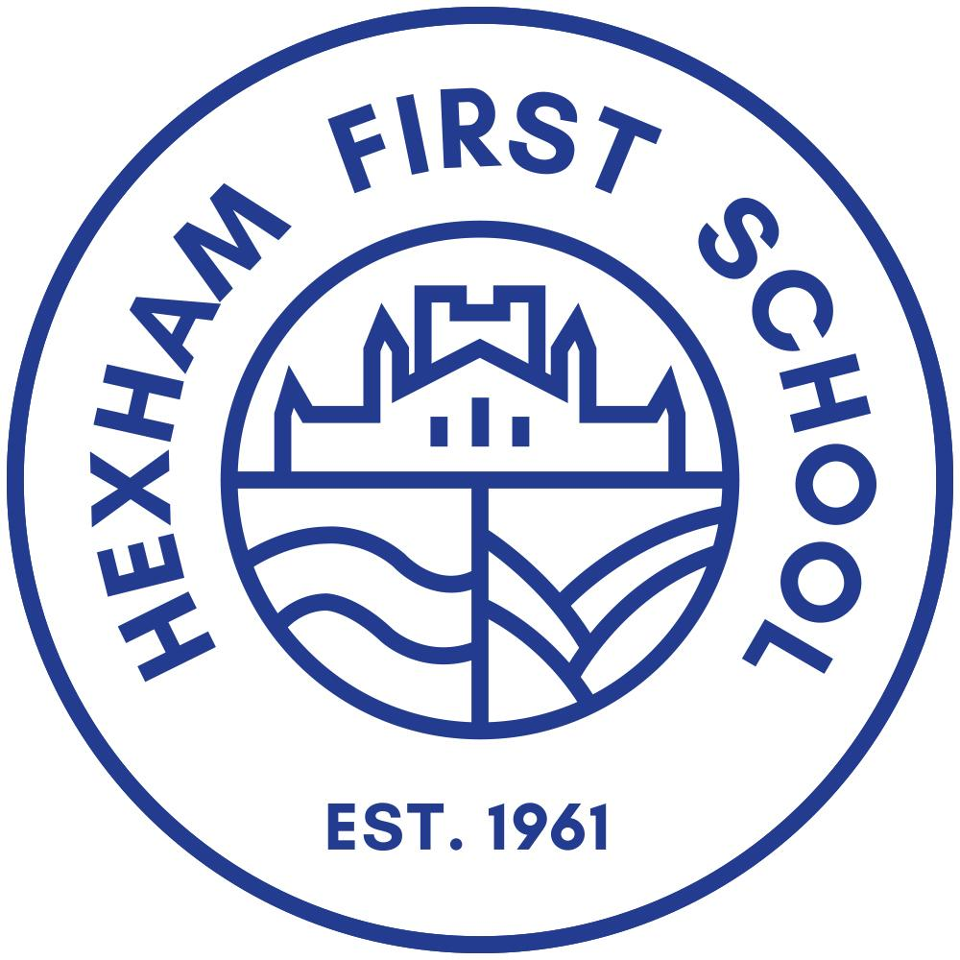

**Healthy Packed Lunch Policy**

**December 2024**

**Review date: December 2027**

**Statement of intent**

Hexham First School understands the importance of developing healthy food habits in children. This policy has been produced following consultation with governors, parents and carers. We encourage further comment and suggestions to assist with our regular review. The beneficial effects which healthy habits have on concentration, overall school performance and prevention of obesity, are examples of why a healthy packed lunch policy will be implemented.

Hexham First School meets the requirements of the School Food Standards and aims to maintain these standards across all packed lunches and school dinners.

**Legal framework**

This policy has been created with regards to the following guidance:

● School Food Plan ‘School Food Standards’ 2015

● DfE ‘School food in England’ 2016

**Aims and objectives**

While maintaining this policy, Hexham First School aims to:

● Promote the benefits of healthy eating and its effect on performance at school.

● Offer parents clear guidance on providing a healthy packed lunch.

● Ensure that the standards of packed lunches comply with the current nutrition standards of school lunches.

● Improve the quality of packed lunches that pupils consume.

To comply with our healthy eating policy, parents are required to:

● Provide pupils with healthy packed lunches containing recommended food groups.

● Inform children of the importance of healthy eating.

**Food and drink in packed lunches**

Based on the School Food Standards, packed lunches which children bring to eat at Hexham First School could ideally contain the following:

● At least one portion of fruit, vegetable or salad

● Meat, fish or another source of non-dairy protein

● Carbohydrates, such as bread, pasta, rice or potatoes

● Dairy, such as cheese, yoghurt or custard

● An oily fish to be included at least once every three weeks

● Only water, fruit juice, milk, yoghurt drinks or smoothies

As part of our Healthy Eating Policy, all packed lunches prepared by the school will contain a balance of foods from each food group.

Packed lunches should contain snacks that comply with Hexham First School’s healthy eating policy – these may include, but are not limited to the following:

● Chopped vegetables, carrot or celery sticks

● A portion of fruit

● Breadsticks

To allow for the promotion of healthy eating, we request that the following food and drinks are not included in your child’s packed lunch:

● Chocolate bars such as Mars bars, Twirl, (chocolate biscuits such as a Kit Kat or Penguin are acceptable)

● Other confectionery items such as sweets or chewing gum

● Carbonated drinks or those containing high levels of caffeine

**What the school will provide**

In accordance with DfE’s guidance ‘School food in England’ 2016, Hexham First School will ensure that pupils have access to free, fresh water at any time.

Clean dining areas are available for all pupils; Hexham First School will aim to prevent segregation of packed lunch and school dinner pupils.

Advice for parents regarding our policies and healthy eating regulations will be available at all times.

Staff and catering members will support families to ensure the packed lunches they provide are healthy.

**Monitoring and review**

The headteacher will review this policy annually and ensure that all procedures remain current and up to date.

The governors will work with the school to review the packed lunch policy and provide advice and support where needed.

Any changes to government guidance regarding school food standards may lead to changes in this policy.

All parents and staff will be notified of any changes made to this policy.